(Approx. 562 words)

Microsoft’s Varied Word-Processing Options
By Nancy DeMarte, 1st Vice President, Sarasota Technology User Group, FL
July 2017 issue, Sarasota Technology Monitor
www.thestug.org
ndemarte (at) verizon.net

When we hear “word-processing,” most of us think of Microsoft Word. A key application in the Office Suite, Word has the greatest number of features (sometimes more than we want) and is the most popular word-processing program in the world. But Word isn’t the only word-processing program that Microsoft offers, and some of the others are free.

WordPad (.rtf), for example, has been included free with Windows since Windows 95. In Windows 10, it isn’t in the apps list; you can only find it by typing “WordPad” in the search box on the Desktop. It is a stripped-down version of Word, but with enough features to complete most standard tasks, as shown in its command ribbon (Fig 1). Its file type, rich text format(.rtf), is readable by almost any word-processing program.

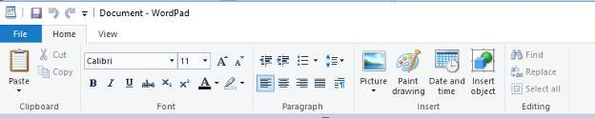
Figure 1 - WordPad Command Ribbon
NotePad (.txt), another long time free feature of Windows, is even more basic. It removes all formatting from the text, leaving no colors nor fancy text effects, just a few fonts and font sizes, bold and italics. (Fig 2) It is perfect for adding text to web pages or creating and editing text files. It too must be searched for in Windows 10.

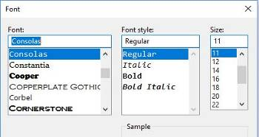
Figure 2 NotePad text options

In 2003, OneNote(.one) became part of the Microsoft Office suite and has been upgraded twice since. This application is available for the computer or as a mobile app for smartphones and tablets. OneNote gives you a simple way to organize your ideas or schedules. It is advertised as a note-taking app for college students and a way to organize events. It lets you create tabs for each aspect of your activity and pages inside each tab. Plus, you can import photos, maps, schedules, and web pages to keep the details handy, as I did for a trip a few years ago. (Fig 3)

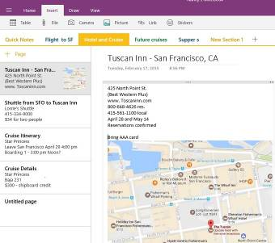
Figure 3 OneNote Workbook with tabs and the Hotel page open
If you make To Do lists, as I do, you’ll love Sticky Notes. It has been a free feature of Windows since Windows 7. You can search for it or find it in the app list. When you click the app, it puts a yellow post-it type note on the screen. Other colors are available. If your computer has a touch screen, you can write on the Sticky Note with a stylus or your finger. If not, you can type your note. Notes can be resized or moved, as you would any digital object. To get a new Sticky Note, click the + sign. (Fig 4)

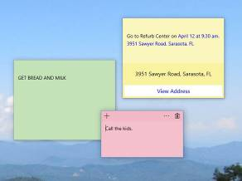
Figure 4 Sticky Notes on the Desktop
In Windows 10, if your note is an appointment reminder with a date and time, Cortana, the voice-activated assistant, can be set to remind you verbally prior to your appointment. If you add a street address, clicking “View Address” will show a map of the location.

Minimize your notes by clicking the Sticky Notes icon on the taskbar. Click again to make them reappear in whatever screen you are viewing. To remove a note, click the trash bin icon on the top right corner of the note. If you use the Sticky Notes app often, you can make it handy by right-clicking the app icon and choosing “Pin to Start.” Whether you are an author or a list-maker, Windows has a word-processing app for you.

